1. What makes a stem cell a stem cell?

Renew, proliferate, differentiate

1. Understand the different types of stem cells.

Understand the different types of pluripotent stem cells -EC / EG / ES / SCNT- ES / iPS.

Understanding of the basic process for derivation of human embryonic stem cells and induced pluripotent stem cells.

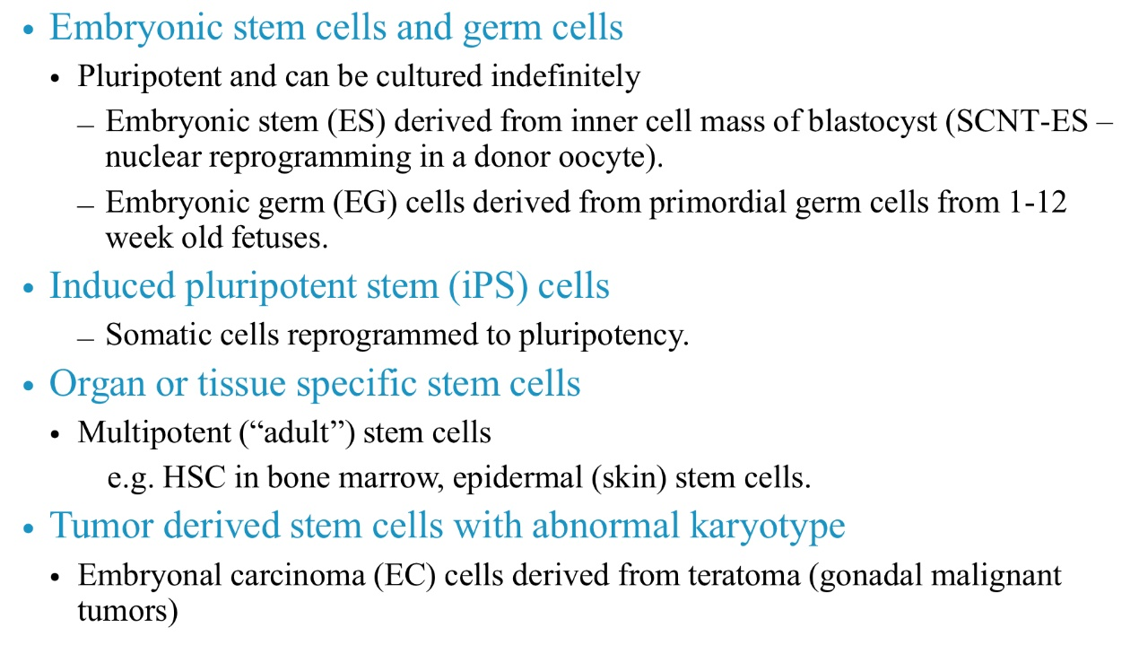

1. Definition of pluripotency/totipotency

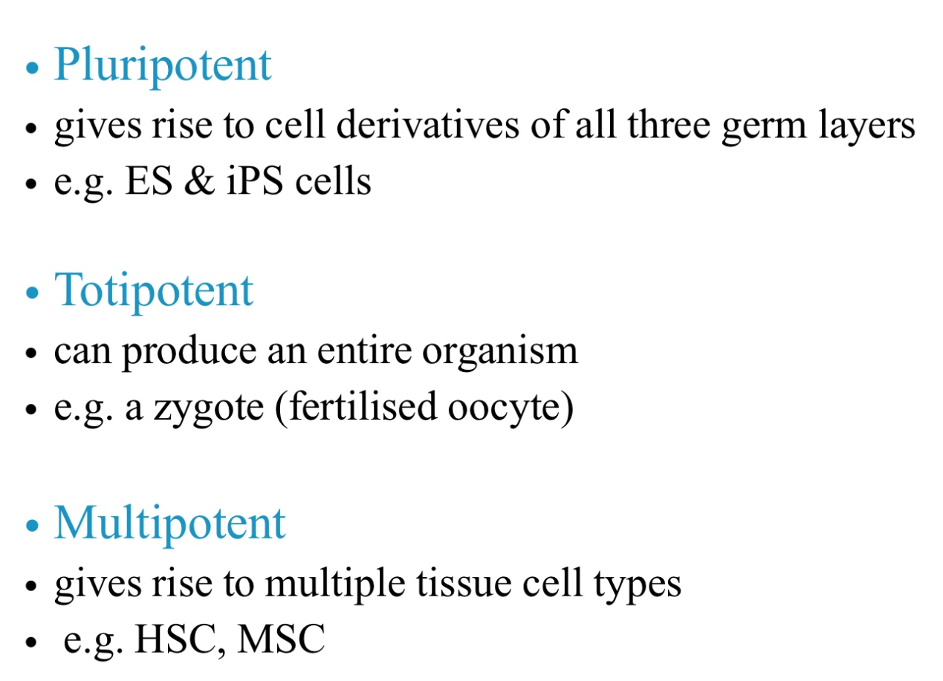

Rank of potency: totipotent->pluripotent->multipotent->unipotent

6.Differences between mouse and human embryonic stem cells

Culture conditions; genetic stability; epigenetic differences; differentiation potential; immune reaction.

7.Methods used to characterise human pluripotent stem cells

How do we know if our experiment gave rise to a pluripotent cell?

OCT4, SOX2, KLF4, c-Myc

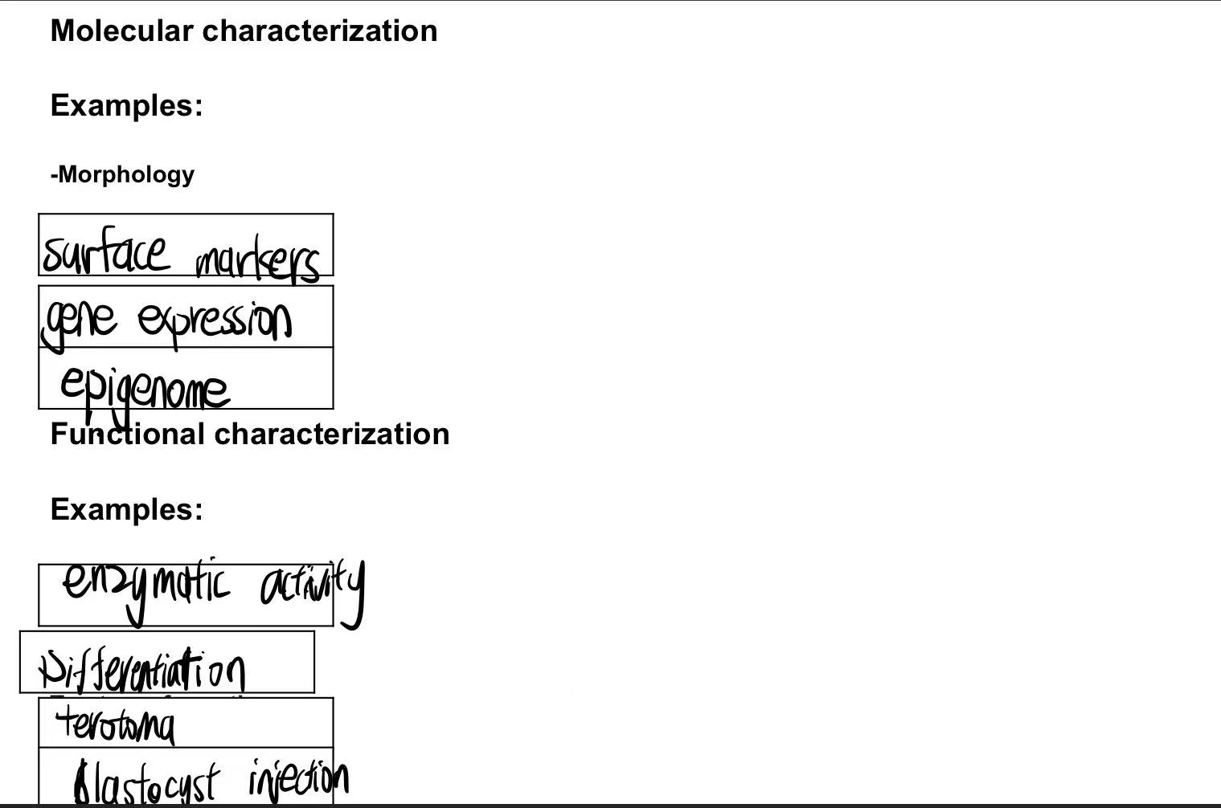

8.Differences between human iPS and ES cells

Source: ips cells: reprogrammed from somatic cells

ES cells: derived from blastocyst

Ethical considerations: ES has; ips doesn’t

Differentiation ability: ES cells is golden benchmark in potency for ips cells

Obtain: IPS is easy to obtain but poor in proliferation; ES is on contrary

9.What is the difference between spontaneous and directed differentiation

spontaneous differentiation is a natural process that occurs in pluripotent stem cells without any external guidance, while directed differentiation is a controlled process that involves the use of specific signals or factors to induce the stem cells to differentiate into specific cell types.

10.What hurdles need to be overcome in order for cellular therapy using pluripotent cells to become a reality

|  |  |  |
| --- | --- | --- |
|  | advantages | disadvantages |
| ES cells | High potency in differertiation | Safety issues |
| IPS cells | Sufficient supply; no embryo; easy to obtain donor tissue;  Easy to generate cell lines;  No need to find matched cells;  In vitro disease research; | Safety issues |

11. Safety issues: undifferentiated cells / animal products / immune rejection

Teratoma forming (hard to extract differentiated cells from all cells);

Animal products: exposure to non-human proteins

Immune rejection: transplantation

12. Potential strategies for overcoming problems

Optimization of culture conditions; epigenetic modification; quality control;

Co-culture system (enhance differentiation ability)

13.Can two pluripotent cells show different transcriptional profiles? NO

Can two pluripotent cells show different function? YES

14.Why cells can be reprogrammed?

cells share full gene information and materials

15.Why we use transcription factor to reprogram cells?

TFs can reverse the differentiation process

16.What are the minimal conditions that we need to achieve a successful cell reprogramming?

cells have full gene information and materials

TFs as tools to reprogramming

culture medium (appropriate culture environment)

17. What are the differences between chemical reprogramming vs TF based reprogramming?

Chemical: synthesis

TF: body produce

18.What are the differences between the integrative methods vs non-integrative methods?

Integrative: permanent/efficient but not safe

Non-integrative: safe not efficient

19.What are the differences between iPS technology vs direct trans differentiation?

Ips: indirect +advantages

Trans: efficient + disadvantages

starting cell types, reprogramming factors, efficiency, limitations, and applications